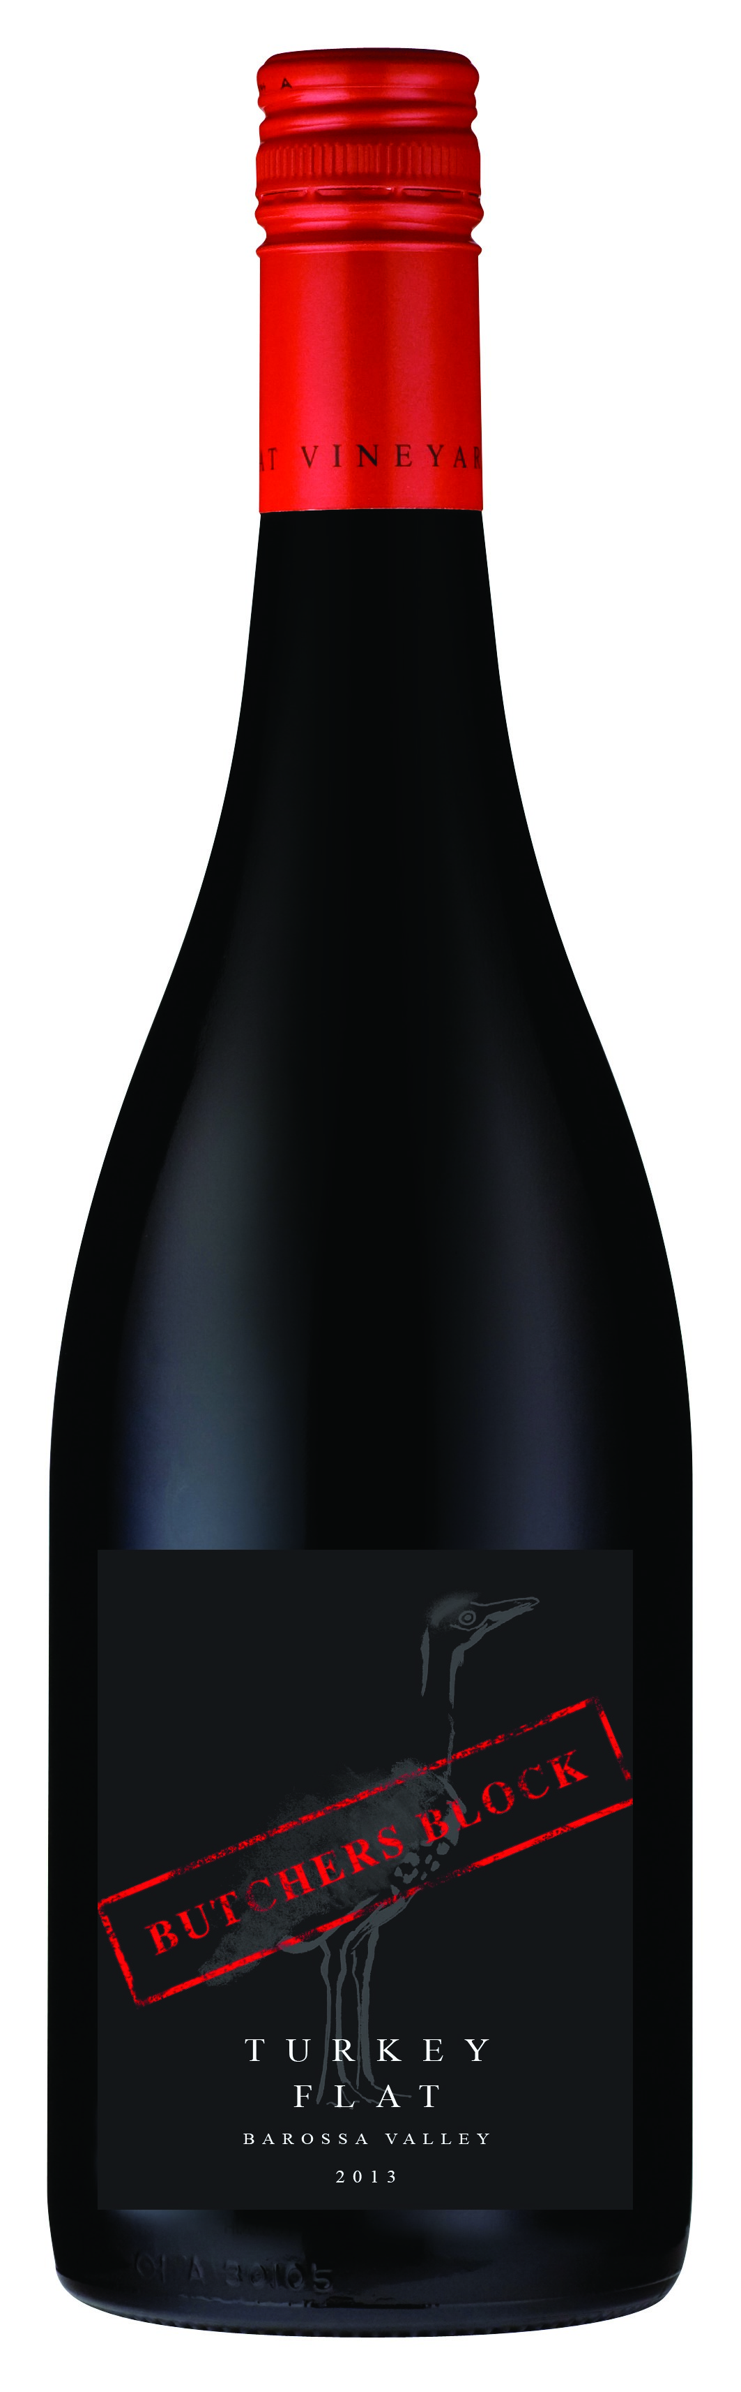
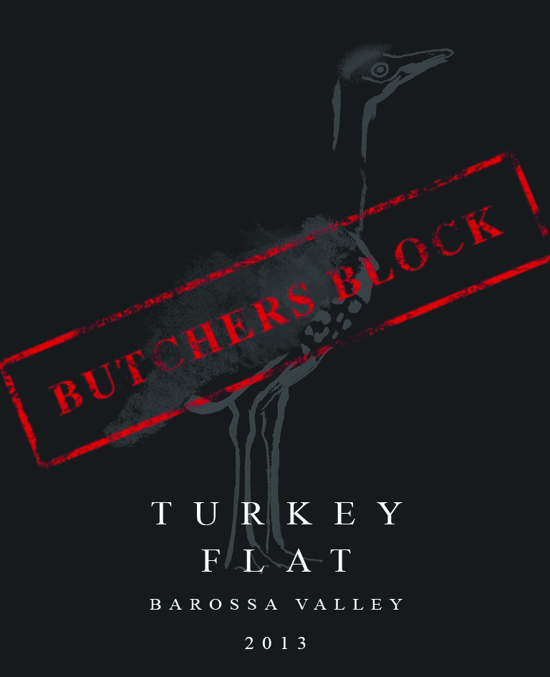
2 0 1 3 B U T C H E R S B L O C K R E D
T U R K E Y F L A T V I N E Y A R D S B A R O S S A V A L L E Y
4 8 % S H I R A Z
2 8 % G R E N A C H E
2 4 % M A T A R O
Named in honour of our family’s original use for the building that now houses our Cellar Door, the Butchers Block Red is a structured, fruit-driven & medium bodied wine. A crowd-pleasing style of wine that offers excellent value for money.
. . . . . . . . . . . . . . . . . . . . . . . . . . . . . . . . . . . . . . . . . . . . . . . . . . . . . . . . . . . . . . . . . . . .
OUR
STYLE
ENJOY
WITH
OUR
WINEMAKING
THE 2013
VINTAGE
TASTING
NOTES
A hot & dry summer combined with low winter rainfall and reduced yields have created wines of exceptional colour and tannin depth during vintage 2013 in the Barossa Valley.
. . . . . . . . . . . . . . . . . . . . . . . . . . . . . . . . . . . . . . . . . . . . . . . . . . . . . . . . . . . . . . . . . . . .
The 2013 Butchers Block Red has an attractive colour & uplifting bouquet of dark plums, rose & sweet spice. The Shiraz brings a classic element of spice and blackcurrant to the palate followed by Grenache’s typical raspberry, cherry combination. Mataro is the spine of the blend, adding supportive tannin & fragrance.
. . . . . . . . . . . . . . . . . . . . . . . . . . . . . . . . . . . . . . . . . . . . . . . . . . . . . . . . . . . . . . . . . . . .
Warm, comfortable meals just like Mum makes – spaghetti bolognaise, braises or lamb cutlets. Or funk it up a notch with braised rabbit or hare with tomato and olives.
. . . . . . . . . . . . . . . . . . . . . . . . . . . . . . . . . . . . . . . . . . . . . . . . . . . . . . . . . . . . . . . . . . . .
Like medals at a children’s sporting event, when we blend a wine we like each parcel to have recognition, its own chance to feel proud of its contribution to the team. Here, each varietal is vinified & aged individually in French oak barrels before the final blending process. Shiraz adds the generous mouthfeel, Grenache the spice and cherry-like sweetness and Mourvèdre the backbone, savoury edge and fragrance. Balance is crucial, each varietal’s contribution is evident, yet nothing competes for your attention.
. . . . . . . . . . . . . . . . . . . . . . . . . . . . . . . . . . . . . . . . . . . . . . . . . . . . . . . . . . . . . . . . . . . .
Harvested:. . . . . . . . . . February-April 2013
Maturity at Harvest:. . . . . 13°-15° Baumé
TECHNICAL
SPECIFICATIONS
Oak Treatment:. . . . . . . . 18 months (Shiraz) & 12 months (Grenache & Mataro)
in French oak hogsheads & large oak vats
Bottled:. . . . . . . . . . . . November 2014
Cellar:. . . . . . . . . . . . . Up to 6 years
MLF:. . . . . . . . Spontaneous in barrels
Alcohol:. . . . . . . . . . . . 14.5%
www.turkeyflat.com.au info@turkeyflat.com.au +61 8 8563 2851 Bethany Road, Tanunda, South Australia, 5352

